Jana Abi Farraj 202304581

Rani Bou Ghannam 202306058

Mohammad Mansour 202300908

Abdulla Al Markabawi 202202313

Software Engineering LAB8

**DFD PROJECT**

Level 0

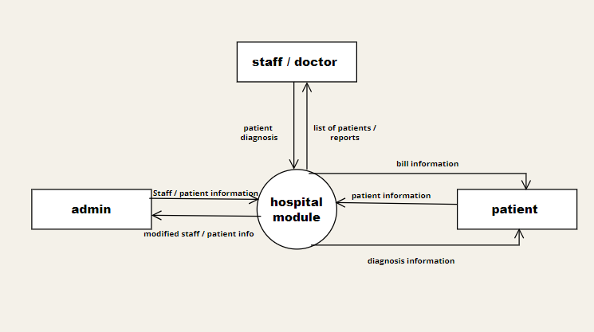

Level 1

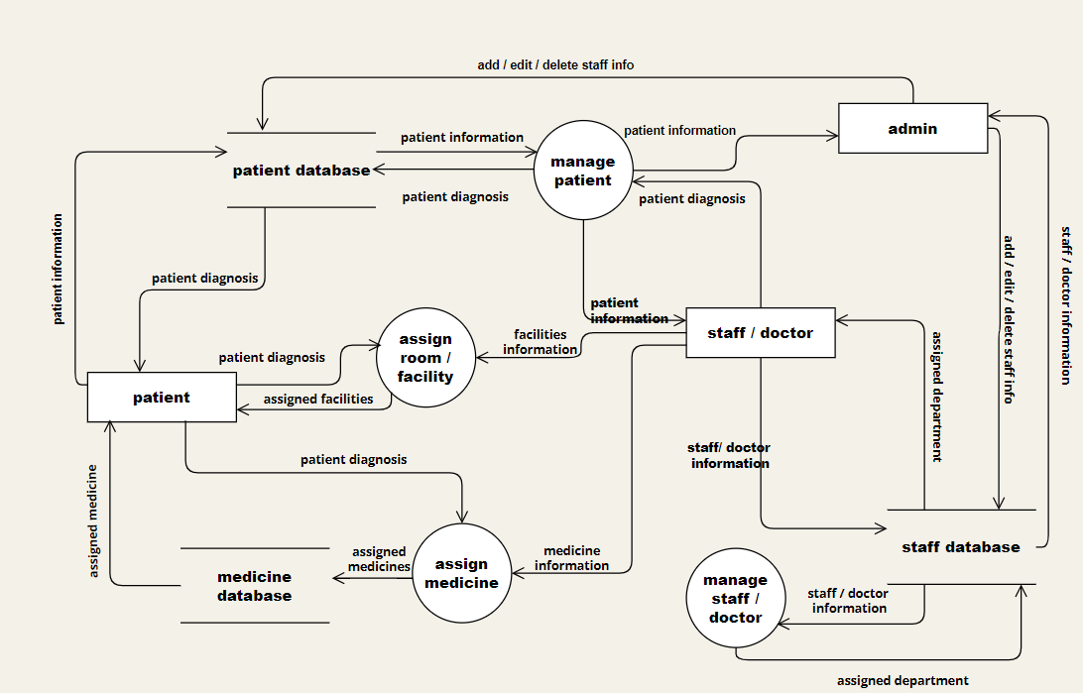

Level 2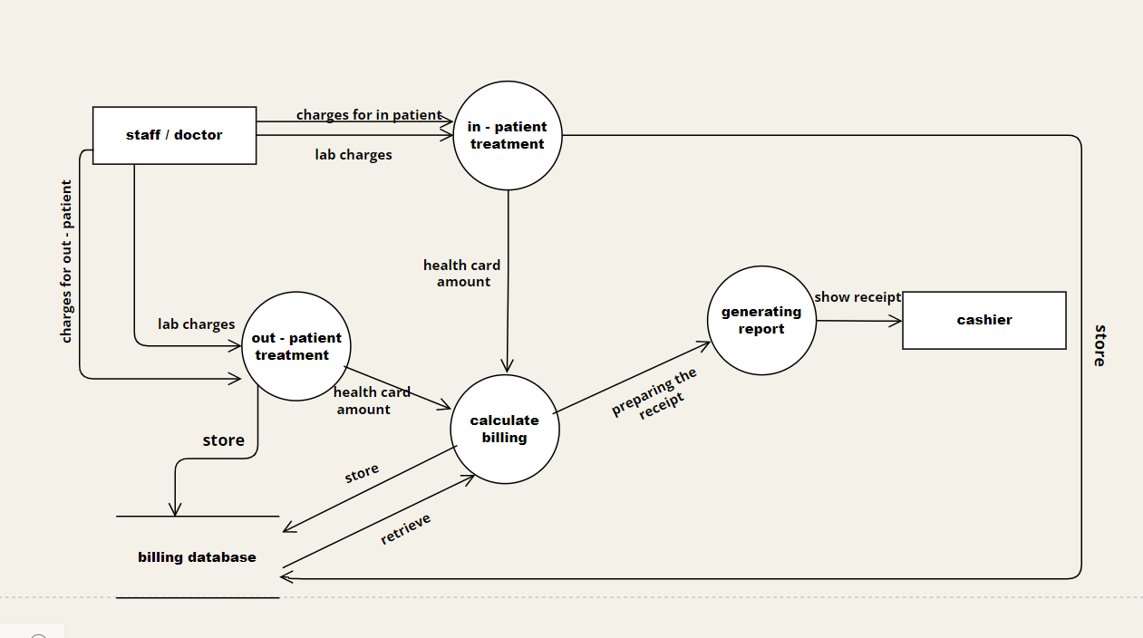

UML CLASS DIAGRAM (PROJECT)

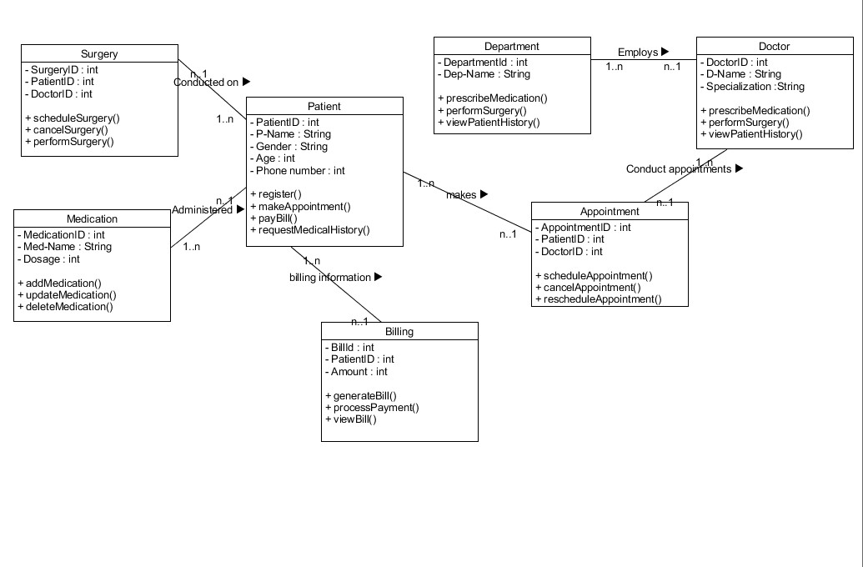

Exercise 1

Company UML Class Diagram

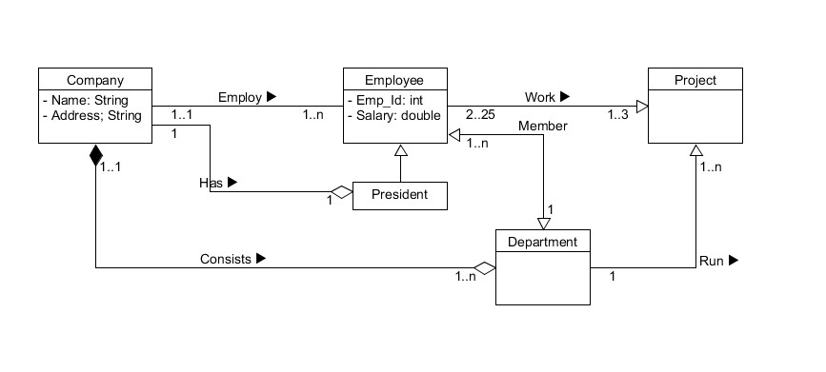

Exercise 2

Restaurant UML Class Diagram

